Gilba Agronomic Intelligence Hub
Combined Analysis Report

Russley Golf Club

3 samples
Green 1 · Green 18 · Green 13
28 July 2026

Zone Comparison
Soil nutrient status and growth potential across all analysed zones. Green = adequate (above MLSN minimum). Red = deficit (below MLSN minimum). Amber = low growth potential.
Zone | Area (ha) | pH | EC (dS/m) | OM (%) | P (ppm) | K (ppm) | Ca (ppm) | Mg (ppm) | S (ppm) | Na (ppm) | CEC
Green 1 | - | 4.7 | - | 4.6 | 18 | 117 | 100 | 22 | - | 12 | 4.0
Green 18 | - | 4.9 | - | 4.6 | 20 | 156 | 220 | 40 | - | 12 | 5.0
Green 13 | - | 4.7 | - | 4.6 | 20 | 117 | 160 | 36 | - | 12 | 4.0
Zone Issues Summary
Aggregated diagnostic flags per zone. Deficiency thresholds, nutrient antagonisms, pH, EC, and CEC assessed against current soil data.
Zone | Key Issues | Priority Action
Green 1 | P, Ca, Mg below MLSN minimum. Nutrient antagonism: K:Mg, K:Ca. pH 4.7, strongly acidic. CEC 4.0, low holding capacity (spoon-feeding required). | Correct P, Ca, Mg deficits, see per-zone recommendations
Green 18 | Ca below MLSN minimum. Nutrient antagonism: K:Mg, K:Ca. pH 4.9, strongly acidic. | Correct Ca deficits, see per-zone recommendations
Green 13 | Ca, Mg below MLSN minimum. Nutrient antagonism: K:Mg, K:Ca. pH 4.7, strongly acidic. CEC 4.0, low holding capacity (spoon-feeding required). | Correct Ca, Mg deficits, see per-zone recommendations
Zone Soil Nutrient Charts
Green 1  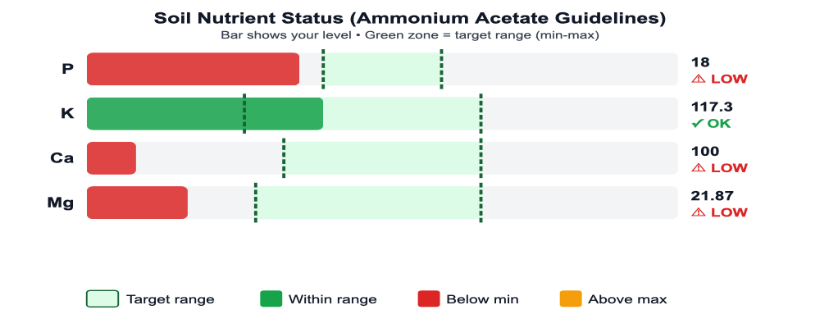 | Green 18  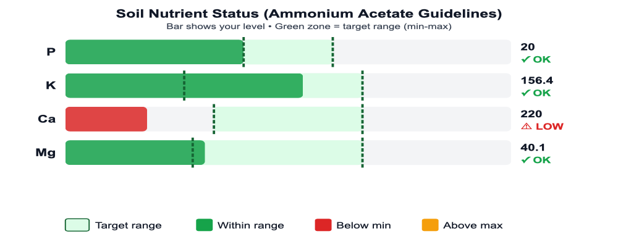
Green 13
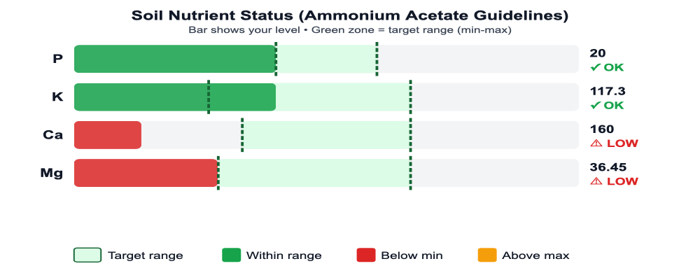

Russley Golf Club , Green 1
Report 1 of 3
Recommendations based on sample: Green 1 (2026-07-06) (single sample for this zone, no trend history available).

Priority Actions
SHORT-TERM (7-30 days)
• Tissue N below Browntop Bent (Greens) sufficiency (3%) - increase N program or apply foliar N.

Live disease pressure, irrigation status, and pre-emergent timing update against current weather in the GAIP Hub dashboard. This export captures soil chemistry and recommendations only.

Site Information
Site | Russley Golf Club
Location | 428 Memorial Avenue, Burnside, Christchurch 8053, New Zealand
Analysis Date | 28/7/2026
Turf Type | Golf - Greens
Species | Browntop Bent (Greens)
Variety | Arrowtown

Soil Nutrition (AMMONIUM_ACETATE), Green 1
Sampled: 6 Jul 2026 • Browntop Bent (Greens)
Extraction Method: Hill Labs NZ Method – TURF Ryegrass, Sand (S277)
pH | 4.7
Phosphorus (P) | 18 ppm
Potassium (K) | 117.3 ppm
Calcium (Ca) | 100 ppm
Magnesium (Mg) | 21.87 ppm
Organic Matter | 4.6%
CEC | 4 meq/100g
Interpretation Framework Comparison
This sample was extracted using the Ammonium Acetate (NH₄OAc pH 8.1) + Olsen P method (Hill Laboratories NZ). MLSN and SLAN guidelines are calibrated for Mehlich-3 extraction and cannot be directly applied to Ammonium Acetate results. The table below shows the three frameworks side by side so you can see how they differ in philosophy and threshold basis.
Framework | Extractant | Philosophy | AU/NZ/UK use | Compatible with this sample?
Ammonium Acetate (Hill Labs NZ) | NH₄OAc pH 8.1 (cations) + Olsen P (NaHCO₃) | Exchangeable cation pool. Sufficiency ranges calibrated for NZ soils. Industry standard in NZ and widely used in Australia. | Standard in NZ; common in AU | ✅ Yes, this report
MLSN (Woods et al. 2016) | Mehlich-3 | Minimum threshold below which deficiency becomes likely. Conservative, avoids over-fertilisation. Used globally in precision turf management. First introduced 2012; canonical published guidelines Woods, Stowell & Gelernter (2016) PeerJ Preprints 4:e2144v1. | AU/NZ: values not directly applicable to AA data | ❌ No, extractant mismatch
SLAN (Carrow et al. 2004) | Mehlich-3 | Sufficiency range, target band above minimum. Higher thresholds than MLSN. Based on agronomic optimum rather than minimum viable level. Canonical published ranges Carrow, Stowell, Gelernter, Davis, Duncan & Skorulski (2004) GCM 72(1):194-198. | AU/NZ: values not directly applicable to AA data | ❌ No, extractant mismatch
Note: If Mehlich-3 results are available for this site, contact your agronomist to run the full MLSN/SLAN dual comparison. Approximate conversion factors exist (e.g. Mehlich-3 K ≈ 1.1× AA K) but introduce error and are not recommended for formal recommendations.


pH and CEC Context
Soil pH: 4.7
Browntop Bent pH requirements: Optimal 5.5–6.5 | Tolerance 5–7 | Acid-tolerant
Cation Exchange Capacity: 4 meq/100g
Soil pH (4.7) is below the tolerance range for Browntop Bent (5–7). At this level, aluminium and manganese can become toxic to roots and phosphorus availability is severely restricted. Dolomite application (see Soil Nutrition recommendations) will correct pH while addressing Mg and Ca deficits simultaneously, retest in 6 months.
CEC is low (4 meq/100g), indicating a sandy soil with limited nutrient-holding capacity. Nutrients applied will leach more readily, requiring smaller, more frequent applications. The benefit is that any sodium accumulation will also leach more easily.
Apply fertilisers in split applications (little and often). Consider slow-release nitrogen sources.
Interpretation
Calcium, Magnesium are below Ammonium Acetate (Hill Labs) guidelines and require attention.
Phosphorus is marginally below Ammonium Acetate (Hill Labs) guidelines but the gap is narrow (within measurement noise and seasonal uptake variation). Monitor at next routine soil test rather than amending now; see the Annual Soil Amendments table.
Potassium levels are adequate.

Interpretation uses Hill Labs NZ extraction methods: Olsen phosphorus (sodium bicarbonate) and ammonium acetate (pH 8.1) for cations. Sufficiency ranges are calibrated for New Zealand soil conditions.
Soil pH is very acidic (4.7). This severely limits phosphorus availability and may allow aluminium and manganese toxicity.
Recommendations:
• Calcium deficit is addressed by dolomite (being recommended for Mg/pH). No standalone Ca amendment required.
• Apply Dolomite (CaMg(CO₃)₂) (12% Mg, 22% Ca) at approximately 96 kg Mg/ha (795 kg product/ha), apply in 4 split dressings of 199 kg product/ha; water in after each application (rate driven by Ca deficit; also corrects Mg and raises pH). Spring placement on close-cut surface: late-summer/early-autumn lime applications carry residual surface alkalinity into the cool-wet pressure window, raising autumn Fusarium pressure. Apply in spring (Sep-Oct south / Mar-Apr north) so the amendment weathers through before autumn disease pressure.. Band: acid pH (4.7 < 6.0). Dolomite chosen because it corrects Mg, supplies Ca, and raises pH together; three benefits from one amendment when soil is acidic to address Mg deficiency.

Annual Soil Amendments
Soil deficits are reconciled against the nutrition programme delivery before recommending standalone amendments. Where the programme already meets the deficit, the standalone product is suppressed; otherwise the rate is reduced to the residual.
Nutrient | Soil deficit  (kg/ha) | Programme delivers  (kg/ha) | Residual  (kg/ha) | Product | Theoretical  (kg/ha) | Practical  (kg/ha/yr) | Status
Phosphorus (P) | 2.8 | 0.0 | 2.8 | - | - | - | Monitor
Calcium (Ca) | 420.0 | 0.0 | 420.0 | - | - | - | Suppressed (dolomite covers)
Magnesium (Mg) | 20.6 | 0.0 | 20.6 | Dolomite (CaMg(CO₃)₂) | 229.1 | 95.5 | Apply
Theoretical = full deficit closure in 1 year at 100% efficiency. Practical = (theoretical / amendment efficiency) / years to correct. Practical figures account for fixation, leaching, and amendment-loss pathways; apply the Practical column figure as the annual programme rate.
Rates expressed as elemental kg/ha. Soil deficit = (threshold − measured) × 10 cm × 1.4 g/cm³ × 0.1. Programme delivery summed across annual applications.
Mulder's Nutrient Interactions
The following antagonistic interactions were detected. These affect nutrient availability independently of absolute soil levels, a nutrient above its sufficiency threshold may still be functionally deficient if a competing element is elevated.
Ratio checks assume all nutrients were extracted using the same method (Olsen P + NH₄OAc (pH 8.1)). Results from mixed-extractant panels will produce unreliable ratios.
K suppresses Mg (K:Mg = 5.4, threshold: 2.5)
Elevated K:Mg ratio, excess K competitively suppresses Mg uptake at root level.
K and Mg share cation uptake carriers (high-affinity transport). K:Mg >2.5 (mass ratio) reduces Mg absorption even when soil Mg is above sufficiency threshold. Common on sand profiles with high K fertiliser programs or calcareous irrigation water.
Marschner 2012
K suppresses Ca (K:Ca = 1.2, threshold: 0.5)
Elevated K:Ca ratio, excess K can suppress Ca translocation to shoot tips.
Ca mobility in the phloem is limited; excess K at root level reduces Ca uptake efficiency. Most significant under low-transpiration conditions (shade, dew periods).
Marschner 2012

Cation Balance Analysis
Cation Ratios
Ca:Mg Ratio | 4.6:1 (Optimal)
K:Mg Ratio (meq) | 1.67 (High K)
Interpretation
K:Mg ratio (1.67) indicates potential K-induced Mg deficiency.
Recommendations:
• Reduce potassium applications and supplement with foliar magnesium.

Climate & Growth Conditions
Temperature | 6.8°C
Growth Potential (C3) | 7%

Tissue Analysis, Green 13
Sampled: 6 Jul 2026 • Browntop Bent (Greens)
Nitrogen (N) | 3%
Phosphorus (P) | 1.4%
Potassium (K) | 2.7%
Calcium (Ca) | 2.4%
Magnesium (Mg) | 0.67%
Sulphur (S) | 0.2%
Iron (Fe) | 156 ppm
Manganese (Mn) | 23 ppm
Zinc (Zn) | 2.5 ppm
Copper (Cu) | 2 ppm

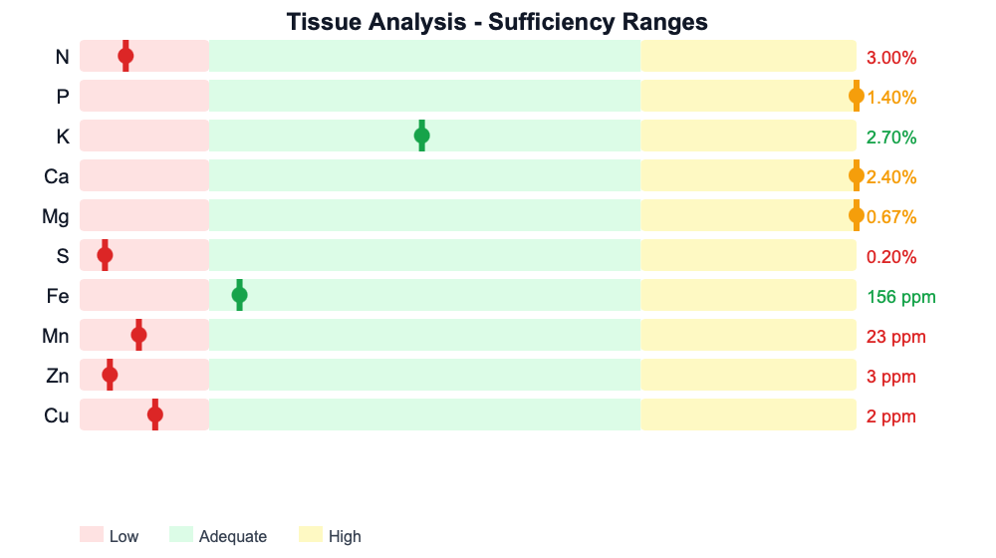
Interpretation
Nitrogen, Sulphur, Manganese, Zinc, Copper are below sufficiency levels, indicating potential deficiency.
Phosphorus, Calcium, Magnesium are above optimal levels. This may indicate luxury consumption or potential antagonism with other nutrients.
Recommendations:
• Increase nitrogen applications. Consider split applications of quick-release N for rapid response, followed by slow-release sources.
• Apply sulphur-containing fertiliser such as ammonium sulphate or potassium sulphate.
• Apply foliar manganese at label rates. Micronutrient deficiencies respond quickly to foliar applications.
• Apply foliar zinc at label rates. Micronutrient deficiencies respond quickly to foliar applications.
• Apply foliar copper at label rates. Micronutrient deficiencies respond quickly to foliar applications.

Nutrient Trend Analysis

Soil Nutrient Trends

Soil Amendment Recommendations
Amendment product selection is based on soil pH, CEC, organic matter content, construction type, and water quality. Products are chosen to address deficits without compounding existing imbalances (e.g. avoiding carbonates at high pH, avoiding sulphates where irrigation water SO₄ is already elevated).
Note: Indicative rates require adjustment for actual soil deficit, bulk density, and rootzone depth. Split applications are recommended for all soluble products (kieserite, Epsom salts) at rates exceeding 20 kg Mg/ha. Confirm product availability and pricing with your supplier before ordering.

Performance Impact Analysis
This section examines how site-specific factors interact to affect turf performance. Understanding these relationships helps prioritise management interventions.
Arrowtown has been selected for this site. Variety-specific traits modify the baseline species response to the conditions described above.
The low soil pH (4.7) causes phosphorus to bind with aluminium and iron oxides, reducing the proportion that remains plant-available. The soil test P value (18 ppm) likely overestimates actual phosphorus availability under these pH conditions.
Current growth potential (7%) severely restricts the turf's ability to recover from damage. Any injury from traffic, disease, or other stressors will persist until temperatures return to the species' optimal growth range. Management should focus on protection rather than recovery during this period.
The coincidence of disease pressure with low recovery capacity creates a critical situation. The turf cannot outgrow pathogen damage at current growth rates, making proactive fungicide applications essential. Curative treatments will be less effective as damaged tissue cannot be replaced quickly.
The analysis has identified 3 significant concurrent limitations: disease pressure, limited growth capacity, nutrient deficiency (N). Under compound stress conditions, the effects are typically multiplicative rather than additive, as each stressor reduces the plant's capacity to cope with the others. Management should focus on addressing the most controllable factor first while avoiding any additional disturbance that could further compromise plant health.
Management Recommendations
1. Prioritise addressing the most controllable stressor first. Defer renovation work and aggressive cultural practices until at least one major limitation has been resolved.

Spray Application Log
Record of chemical and fertiliser applications for this site. 4 entries.
Date | Product | Active Ingredient | Rate | Zone | Category
20/07/2026 | Amigo 175 | Trinexapac-ethyl | 0.5 L/ha | greens
06/07/2026 | Daconil Weather Stik | chlorotalonil | 18 L/ha | greens
01/07/2026 | Amigo 175 | Trinexapac-ethyl | 0.5 L/ha | greens
23/06/2026 | Amigo 175 | Trinexapac-ethyl | 4 L/ha | greens

Cultivar Performance Profile
Arrowtown (Cultivar)
Data source: BSPB Turfgrass Seed 2025 Table G1 - STRI Bingley trials
Trial Performance Ratings
Characteristic | Rating | Scale | Assessment
NTEP Quality Rating | 7.0 | 1-9 | Good

Performance Modifiers
These modifiers adjust baseline species calculations in the Hub analysis:
Wear Tolerance: Average, Baseline for species
No verified trial data; fabricated value removed b35fix471
Recovery Rate: Average, 0% recovery rate
PGG Wrightson/Notman Pasture Seeds specifications
Cold Tolerance: Average, Baseline for species
No verified trial data; fabricated value removed b35fix471

Disease Resistance Profile
Disease | Resistance | Risk Modifier | Confidence
Fusarium (Microdochium) | Susceptible | 12% higher risk | medium
Dollar Spot | Average | 0% higher risk | medium
Take-all Patch | Average | 0% higher risk | low
Anthracnose | Average | 5% lower risk | low

Russley Golf Club , Green 18
Report 2 of 3
Recommendations based on latest sample: Green 18 (2026-07-06). 1 prior sample for this zone (2025-07-06) informs the Nutrient Trend Analysis section.

Priority Actions
SHORT-TERM (7-30 days)
• Tissue N below Browntop Bent (Greens) sufficiency (3%) - increase N program or apply foliar N.

Live disease pressure, irrigation status, and pre-emergent timing update against current weather in the GAIP Hub dashboard. This export captures soil chemistry and recommendations only.

Soil Nutrition (AMMONIUM_ACETATE), Green 18
Sampled: 6 Jul 2026 • Browntop Bent (Greens)
Extraction Method: Hill Labs NZ Method – TURF Ryegrass, Sand (S277)
pH | 4.9
Phosphorus (P) | 20 ppm
Potassium (K) | 156.4 ppm
Calcium (Ca) | 220 ppm
Magnesium (Mg) | 40.1 ppm
Organic Matter | 4.6%
CEC | 5 meq/100g
Interpretation Framework Comparison
This sample was extracted using the Ammonium Acetate (NH₄OAc pH 8.1) + Olsen P method (Hill Laboratories NZ). MLSN and SLAN guidelines are calibrated for Mehlich-3 extraction and cannot be directly applied to Ammonium Acetate results. The table below shows the three frameworks side by side so you can see how they differ in philosophy and threshold basis.
Framework | Extractant | Philosophy | AU/NZ/UK use | Compatible with this sample?
Ammonium Acetate (Hill Labs NZ) | NH₄OAc pH 8.1 (cations) + Olsen P (NaHCO₃) | Exchangeable cation pool. Sufficiency ranges calibrated for NZ soils. Industry standard in NZ and widely used in Australia. | Standard in NZ; common in AU | ✅ Yes, this report
MLSN (Woods et al. 2016) | Mehlich-3 | Minimum threshold below which deficiency becomes likely. Conservative, avoids over-fertilisation. Used globally in precision turf management. First introduced 2012; canonical published guidelines Woods, Stowell & Gelernter (2016) PeerJ Preprints 4:e2144v1. | AU/NZ: values not directly applicable to AA data | ❌ No, extractant mismatch
SLAN (Carrow et al. 2004) | Mehlich-3 | Sufficiency range, target band above minimum. Higher thresholds than MLSN. Based on agronomic optimum rather than minimum viable level. Canonical published ranges Carrow, Stowell, Gelernter, Davis, Duncan & Skorulski (2004) GCM 72(1):194-198. | AU/NZ: values not directly applicable to AA data | ❌ No, extractant mismatch
Note: If Mehlich-3 results are available for this site, contact your agronomist to run the full MLSN/SLAN dual comparison. Approximate conversion factors exist (e.g. Mehlich-3 K ≈ 1.1× AA K) but introduce error and are not recommended for formal recommendations.


pH and CEC Context
Soil pH: 4.9
Browntop Bent pH requirements: Optimal 5.5–6.5 | Tolerance 5–7 | Acid-tolerant
Cation Exchange Capacity: 5 meq/100g
Soil pH (4.9) is below the tolerance range for Browntop Bent (5–7). At this level, aluminium and manganese can become toxic to roots, while phosphorus availability is severely restricted. This species will experience significant stress.
CEC is moderate (5 meq/100g), typical of sandy loam rootzones common in sports turf and golf greens. This provides reasonable nutrient retention while maintaining good drainage.
URGENT: Apply agricultural lime to raise pH toward 5.5. Retest in 6 months to assess response.
Interpretation
Calcium is below Ammonium Acetate (Hill Labs) guidelines and requires attention.
Phosphorus, Potassium, Magnesium levels are adequate.

Interpretation uses Hill Labs NZ extraction methods: Olsen phosphorus (sodium bicarbonate) and ammonium acetate (pH 8.1) for cations. Sufficiency ranges are calibrated for New Zealand soil conditions.
Soil pH is very acidic (4.9). This limits nutrient availability, particularly phosphorus.
Recommendations:
• Apply Gypsum (CaSO₄·2H₂O) (23% Ca, 18.6% S) at approximately 140 kg Ca/ha (609 kg product/ha), apply in 3 split dressings of 203 kg product/ha; water in after each application, pH-neutral; gypsum also delivers S, at pH 4.9 (acidic) lime would also raise pH but is NOT chosen here because the Ca branch only fires when there is no Mg co-deficit. Use lime when pH correction is the goal; use gypsum when Ca supply alone is required without pH change to address Ca deficiency.
• Apply agricultural lime at 1-2 t/ha to raise pH toward 5.5-6.5.

Annual Soil Amendments
Soil deficits are reconciled against the nutrition programme delivery before recommending standalone amendments. Where the programme already meets the deficit, the standalone product is suppressed; otherwise the rate is reduced to the residual.
Nutrient | Soil deficit  (kg/ha) | Programme delivers  (kg/ha) | Residual  (kg/ha) | Product | Theoretical  (kg/ha) | Practical  (kg/ha/yr) | Status
Calcium (Ca) | 252.0 | 0.0 | 252.0 | Gypsum (CaSO₄·2H₂O) | 252.0 | 140.0 | Apply
Theoretical = full deficit closure in 1 year at 100% efficiency. Practical = (theoretical / amendment efficiency) / years to correct. Practical figures account for fixation, leaching, and amendment-loss pathways; apply the Practical column figure as the annual programme rate.
Rates expressed as elemental kg/ha. Soil deficit = (threshold − measured) × 10 cm × 1.4 g/cm³ × 0.1. Programme delivery summed across annual applications.
Mulder's Nutrient Interactions
The following antagonistic interactions were detected. These affect nutrient availability independently of absolute soil levels, a nutrient above its sufficiency threshold may still be functionally deficient if a competing element is elevated.
Ratio checks assume all nutrients were extracted using the same method (Olsen P + NH₄OAc (pH 8.1)). Results from mixed-extractant panels will produce unreliable ratios.
K suppresses Mg (K:Mg = 3.9, threshold: 2.5)
Elevated K:Mg ratio, excess K competitively suppresses Mg uptake at root level.
K and Mg share cation uptake carriers (high-affinity transport). K:Mg >2.5 (mass ratio) reduces Mg absorption even when soil Mg is above sufficiency threshold. Common on sand profiles with high K fertiliser programs or calcareous irrigation water.
Marschner 2012
K suppresses Ca (K:Ca = 0.7, threshold: 0.5)
Elevated K:Ca ratio, excess K can suppress Ca translocation to shoot tips.
Ca mobility in the phloem is limited; excess K at root level reduces Ca uptake efficiency. Most significant under low-transpiration conditions (shade, dew periods).
Marschner 2012

Cation Balance Analysis
Cation Ratios
Ca:Mg Ratio | 5.5:1 (Optimal)
K:Mg Ratio (meq) | 1.21 (High K)
Interpretation
K:Mg ratio (1.21) indicates potential K-induced Mg deficiency.
Recommendations:
• Reduce potassium applications and supplement with foliar magnesium.

Tissue Analysis, Green 13
Sampled: 6 Jul 2026 • Browntop Bent (Greens)
Nitrogen (N) | 3%
Phosphorus (P) | 1.4%
Potassium (K) | 2.7%
Calcium (Ca) | 2.4%
Magnesium (Mg) | 0.67%
Sulphur (S) | 0.2%
Iron (Fe) | 156 ppm
Manganese (Mn) | 23 ppm
Zinc (Zn) | 2.5 ppm
Copper (Cu) | 2 ppm


Interpretation
Nitrogen, Sulphur, Manganese, Zinc, Copper are below sufficiency levels, indicating potential deficiency.
Phosphorus, Calcium, Magnesium are above optimal levels. This may indicate luxury consumption or potential antagonism with other nutrients.
Recommendations:
• Increase nitrogen applications. Consider split applications of quick-release N for rapid response, followed by slow-release sources.
• Apply sulphur-containing fertiliser such as ammonium sulphate or potassium sulphate.
• Apply foliar manganese at label rates. Micronutrient deficiencies respond quickly to foliar applications.
• Apply foliar zinc at label rates. Micronutrient deficiencies respond quickly to foliar applications.
• Apply foliar copper at label rates. Micronutrient deficiencies respond quickly to foliar applications.

Spray Application Log
Record of chemical and fertiliser applications for this site. 4 entries.
Date | Product | Active Ingredient | Rate | Zone | Category
20/07/2026 | Amigo 175 | Trinexapac-ethyl | 0.5 L/ha | greens
06/07/2026 | Daconil Weather Stik | chlorotalonil | 18 L/ha | greens
01/07/2026 | Amigo 175 | Trinexapac-ethyl | 0.5 L/ha | greens
23/06/2026 | Amigo 175 | Trinexapac-ethyl | 4 L/ha | greens

Russley Golf Club , Green 13
Report 3 of 3
Recommendations based on sample: Green 13 (2026-07-06) (single sample for this zone, no trend history available).

Priority Actions
SHORT-TERM (7-30 days)
• Tissue N below Browntop Bent (Greens) sufficiency (3%) - increase N program or apply foliar N.

Live disease pressure, irrigation status, and pre-emergent timing update against current weather in the GAIP Hub dashboard. This export captures soil chemistry and recommendations only.

Soil Nutrition (AMMONIUM_ACETATE), Green 13
Sampled: 6 Jul 2026 • Browntop Bent (Greens)
Extraction Method: Hill Labs NZ Method – TURF Ryegrass, Sand (S277)
pH | 4.7
Phosphorus (P) | 20 ppm
Potassium (K) | 117.3 ppm
Calcium (Ca) | 160 ppm
Magnesium (Mg) | 36.45 ppm
Organic Matter | 4.6%
CEC | 4 meq/100g
Interpretation Framework Comparison
This sample was extracted using the Ammonium Acetate (NH₄OAc pH 8.1) + Olsen P method (Hill Laboratories NZ). MLSN and SLAN guidelines are calibrated for Mehlich-3 extraction and cannot be directly applied to Ammonium Acetate results. The table below shows the three frameworks side by side so you can see how they differ in philosophy and threshold basis.
Framework | Extractant | Philosophy | AU/NZ/UK use | Compatible with this sample?
Ammonium Acetate (Hill Labs NZ) | NH₄OAc pH 8.1 (cations) + Olsen P (NaHCO₃) | Exchangeable cation pool. Sufficiency ranges calibrated for NZ soils. Industry standard in NZ and widely used in Australia. | Standard in NZ; common in AU | ✅ Yes, this report
MLSN (Woods et al. 2016) | Mehlich-3 | Minimum threshold below which deficiency becomes likely. Conservative, avoids over-fertilisation. Used globally in precision turf management. First introduced 2012; canonical published guidelines Woods, Stowell & Gelernter (2016) PeerJ Preprints 4:e2144v1. | AU/NZ: values not directly applicable to AA data | ❌ No, extractant mismatch
SLAN (Carrow et al. 2004) | Mehlich-3 | Sufficiency range, target band above minimum. Higher thresholds than MLSN. Based on agronomic optimum rather than minimum viable level. Canonical published ranges Carrow, Stowell, Gelernter, Davis, Duncan & Skorulski (2004) GCM 72(1):194-198. | AU/NZ: values not directly applicable to AA data | ❌ No, extractant mismatch
Note: If Mehlich-3 results are available for this site, contact your agronomist to run the full MLSN/SLAN dual comparison. Approximate conversion factors exist (e.g. Mehlich-3 K ≈ 1.1× AA K) but introduce error and are not recommended for formal recommendations.


pH and CEC Context
Soil pH: 4.7
Browntop Bent pH requirements: Optimal 5.5–6.5 | Tolerance 5–7 | Acid-tolerant
Cation Exchange Capacity: 4 meq/100g
Soil pH (4.7) is below the tolerance range for Browntop Bent (5–7). At this level, aluminium and manganese can become toxic to roots and phosphorus availability is severely restricted. Dolomite application (see Soil Nutrition recommendations) will correct pH while addressing Mg and Ca deficits simultaneously, retest in 6 months.
CEC is low (4 meq/100g), indicating a sandy soil with limited nutrient-holding capacity. Nutrients applied will leach more readily, requiring smaller, more frequent applications. The benefit is that any sodium accumulation will also leach more easily.
Apply fertilisers in split applications (little and often). Consider slow-release nitrogen sources.
Interpretation
Calcium is below Ammonium Acetate (Hill Labs) guidelines and requires attention.
Magnesium is marginally below Ammonium Acetate (Hill Labs) guidelines but the gap is narrow (within measurement noise and seasonal uptake variation). Monitor at next routine soil test rather than amending now; see the Annual Soil Amendments table.
Phosphorus, Potassium levels are adequate.

Interpretation uses Hill Labs NZ extraction methods: Olsen phosphorus (sodium bicarbonate) and ammonium acetate (pH 8.1) for cations. Sufficiency ranges are calibrated for New Zealand soil conditions.
Soil pH is very acidic (4.7). This severely limits phosphorus availability and may allow aluminium and manganese toxicity.
Recommendations:
• Calcium deficit is addressed by dolomite (being recommended for Mg/pH). No standalone Ca amendment required.

Annual Soil Amendments
Soil deficits are reconciled against the nutrition programme delivery before recommending standalone amendments. Where the programme already meets the deficit, the standalone product is suppressed; otherwise the rate is reduced to the residual.
Nutrient | Soil deficit  (kg/ha) | Programme delivers  (kg/ha) | Residual  (kg/ha) | Product | Theoretical  (kg/ha) | Practical  (kg/ha/yr) | Status
Calcium (Ca) | 336.0 | 0.0 | 336.0 | - | - | - | Suppressed (dolomite covers)
Magnesium (Mg) | 0.2 | 0.0 | 0.2 | - | - | - | Monitor
Rates expressed as elemental kg/ha. Soil deficit = (threshold − measured) × 10 cm × 1.4 g/cm³ × 0.1. Programme delivery summed across annual applications.
Mulder's Nutrient Interactions
The following antagonistic interactions were detected. These affect nutrient availability independently of absolute soil levels, a nutrient above its sufficiency threshold may still be functionally deficient if a competing element is elevated.
Ratio checks assume all nutrients were extracted using the same method (Olsen P + NH₄OAc (pH 8.1)). Results from mixed-extractant panels will produce unreliable ratios.
K suppresses Mg (K:Mg = 3.2, threshold: 2.5)
Elevated K:Mg ratio, excess K competitively suppresses Mg uptake at root level.
K and Mg share cation uptake carriers (high-affinity transport). K:Mg >2.5 (mass ratio) reduces Mg absorption even when soil Mg is above sufficiency threshold. Common on sand profiles with high K fertiliser programs or calcareous irrigation water.
Marschner 2012
K suppresses Ca (K:Ca = 0.7, threshold: 0.5)
Elevated K:Ca ratio, excess K can suppress Ca translocation to shoot tips.
Ca mobility in the phloem is limited; excess K at root level reduces Ca uptake efficiency. Most significant under low-transpiration conditions (shade, dew periods).
Marschner 2012

Cation Balance Analysis
Cation Ratios
Ca:Mg Ratio | 4.4:1 (Optimal)
K:Mg Ratio (meq) | 1.00 (High K)
Interpretation
K:Mg ratio (1.00) indicates potential K-induced Mg deficiency.
Recommendations:
• Reduce potassium applications and supplement with foliar magnesium.

Tissue Analysis, Green 13
Sampled: 6 Jul 2026 • Browntop Bent (Greens)
Nitrogen (N) | 3%
Phosphorus (P) | 1.4%
Potassium (K) | 2.7%
Calcium (Ca) | 2.4%
Magnesium (Mg) | 0.67%
Sulphur (S) | 0.2%
Iron (Fe) | 156 ppm
Manganese (Mn) | 23 ppm
Zinc (Zn) | 2.5 ppm
Copper (Cu) | 2 ppm


Interpretation
Nitrogen, Sulphur, Manganese, Zinc, Copper are below sufficiency levels, indicating potential deficiency.
Phosphorus, Calcium, Magnesium are above optimal levels. This may indicate luxury consumption or potential antagonism with other nutrients.
Recommendations:
• Increase nitrogen applications. Consider split applications of quick-release N for rapid response, followed by slow-release sources.
• Apply sulphur-containing fertiliser such as ammonium sulphate or potassium sulphate.
• Apply foliar manganese at label rates. Micronutrient deficiencies respond quickly to foliar applications.
• Apply foliar zinc at label rates. Micronutrient deficiencies respond quickly to foliar applications.
• Apply foliar copper at label rates. Micronutrient deficiencies respond quickly to foliar applications.

Spray Application Log
Record of chemical and fertiliser applications for this site. 4 entries.
Date | Product | Active Ingredient | Rate | Zone | Category
20/07/2026 | Amigo 175 | Trinexapac-ethyl | 0.5 L/ha | greens
06/07/2026 | Daconil Weather Stik | chlorotalonil | 18 L/ha | greens
01/07/2026 | Amigo 175 | Trinexapac-ethyl | 0.5 L/ha | greens
23/06/2026 | Amigo 175 | Trinexapac-ethyl | 4 L/ha | greens

Annual Nutrient Requirements
Hill Labs S277 sample-type sufficiency thresholds applied (TURF Ryegrass, Sand (S277)). Cation values converted from cert-native me/100g to ppm for amendment-math comparison; cation deficit-correction recommendations appear in the Soil Amendment table above. The figures below are annual removal-replacement estimates (clipping uptake), not deficit-closure rates. All rates kg/ha/yr.
Sample | N kg/ha | P ppm | P req | K ppm | K req | S ppm | S req
Green 1 | 150 | 18 | 15.0 | 117 | 80.0 | - | -
Green 18 | 150 | 20 | 15.0 | 156 | 80.0 | - | -
Green 13 | 150 | 20 | 15.0 | 117 | 80.0 | - | -
Note: K reconciliation omitted, no fertiliser programme found for this site. Add an N programme to enable per-sample K balance reporting.
Monthly N Distribution (GP-Weighted)
Total: 150 kg N/ha/yr | 12 active growing months
Jan | Feb | Mar | Apr | May | Jun | Jul | Aug | Sep | Oct | Nov | Dec
13  GP 66% | 13  GP 66% | 18  GP 94% | 18  GP 94% | 10  GP 55% | 5  GP 26% | 4  GP 19% | 7  GP 35% | 13  GP 66% | 18  GP 94% | 19  GP 98% | 15  GP 77%
Distribution is site-uniform, annual N target, monthly growth potential, and distribution strategy are all site-level inputs. Per-sample differentiation appears in P/K/S requirements above.

References & Methodology
This report represents a point-in-time analysis based on the soil, tissue, and water quality data provided. Turf conditions are dynamic, and the relationships identified in this report may change as environmental conditions, management practices, and plant development progress. For comprehensive trend analysis and to track the effectiveness of management interventions, periodic re-testing is recommended, with soil analysis annually, tissue testing during active growth periods, and water quality assessment when source conditions change.
The analysis and recommendations in this report are based on peer-reviewed methodologies and evidence-based guidelines. The following sources underpin the interpretations provided:
Soil Nutrition
• Woods, M.S., Stowell, L.J. & Gelernter, W.D. (2014). Minimum Levels for Sustainable Nutrition (MLSN) guidelines. PACE Turf.
• Carrow, R.N., Waddington, D.V. & Rieke, P.E. (2001). Turfgrass Soil Fertility and Chemical Problems: Assessment and Management. John Wiley & Sons.
• Kreuser, W.C. (2015). Sufficiency Level of Available Nutrients (SLAN) guidelines for turfgrass. University of Nebraska-Lincoln.
Tissue Analysis
• Jones, J.B., Wolf, B. & Mills, H.A. (1991). Plant Analysis Handbook. Micro-Macro Publishing.
• Turner, T.R. & Hummel, N.W. (1992). Nutritional requirements and fertilisation. In: Waddington et al. (eds) Turfgrass. ASA-CSSA-SSSA.
• Christians, N.E., Patton, A.J. & Law, Q.D. (2016). Fundamentals of Turfgrass Management, 5th ed. John Wiley & Sons.
Water Quality
• Ayers, R.S. & Westcot, D.W. (1985). Water Quality for Agriculture. FAO Irrigation and Drainage Paper 29.
• Carrow, R.N. & Duncan, R.R. (2012). Best Management Practices for Saline and Sodic Turfgrass Soils. CRC Press.
• Harivandi, M.A. (1999). Interpreting Turfgrass Irrigation Water Test Results. University of California ANR Publication 8009.
Growth Potential & Climate
• Kreuser, W.C. & Soldat, D.J. (2011). A growing degree day model to schedule trinexapac-ethyl applications on Agrostis stolonifera golf putting greens. Crop Science 51:2228-2236.
• Beard, J.B. (1973). Turfgrass: Science and Culture. Prentice-Hall.
Disease Risk
• Smiley, R.W., Dernoeden, P.H. & Clarke, B.B. (2005). Compendium of Turfgrass Diseases, 3rd ed. APS Press.
• Fidanza, M.A. & Dernoeden, P.H. (1996). Brown patch and dollar spot model development. HortScience 31:1006-1009.
• Smith, J.D., Jackson, N. & Woolhouse, A.R. (1989). Fungal Diseases of Amenity Turf Grasses. E. & F.N. Spon.
Variety Traits & Performance
• National Turfgrass Evaluation Program (NTEP). Multi-year variety trial data. ntep.org.
• Wu, Y., Taliaferro, C.M. & Martin, D.L. (2011). Bermudagrass shade tolerance research. Oklahoma State University.
• Amgain, N.R. et al. (2018). Evapotranspiration rates of bermudagrass cultivars. Crop Science 58:1409-1421.
Salinity & Stress Interactions
• Maas, E.V. & Hoffman, G.J. (1977). Crop salt tolerance - current assessment. J. Irrig. Drain. Div. 103:115-134.
• Harivandi, M.A. et al. (1992). Turfgrass salinity tolerance. California Turfgrass Culture 42:1-4.
• Carrow, R.N. & Duncan, R.R. (1998). Salt-affected turfgrass sites: Assessment and management. Ann Arbor Press.

Report Metadata
Generated: 28/7/2026, 3:06:49 PM
Hub Version: unknown
Data Quality: MEDIUM (60%)
Data Notes:
• No water quality data - irrigation impacts not assessed
• Confidence capped by Dew Prediction (50%)
Methodology References:
• PACE Turf MLSN (2014)
• Kussow et al. 2012 (2012)
• ATC ClipVol (2018)
• Ayers & Westcot 1985 (1985)
• PACE Growth Potential (2005)
• Smith & Kerns 2018 (2018)
• Fidanza & Dernoeden 1996 (1996)
• Nutter et al. 1983 (1983)
• Kreuser & Soldat 2011 (2011)
• GreenKeeper Sinewave (2020)
• FAO-56 (1998)
• Landschoot 2024 (PSU Extension) (2024)
• UMass Extension Turf
• Brecht et al. 2007 (2007)
DISCLAIMER: This report was generated by the Gilba Agronomic Intelligence Hub. Recommendations are based on peer-reviewed research methodologies and should be validated against local conditions and professional judgment. Confidence scores are advisory indicators, not validation gates. Gilba Solutions accepts no liability for agronomic outcomes.

Glossary of Terms
Reference definitions for technical terms used in this report.
Bicarbonate (HCO₃)
A naturally occurring ion in water that affects calcium availability. High bicarbonate causes calcium to precipitate as lime in the soil, reducing its ability to counteract sodium. Measured in mg/L or meq/L.
Cation Exchange Capacity (CEC)
A measure of the soil's ability to hold and release positively charged nutrients (cations) such as calcium, magnesium, potassium, and sodium. Expressed in meq/100g or cmol/kg. Higher CEC soils retain nutrients better but may also hold sodium more tightly.
Ammonium Acetate Extraction
A soil testing method using neutral ammonium acetate (NH₄OAc at pH 7 or pH 8.1) to extract exchangeable cations (K, Ca, Mg, Na). Combined with Olsen phosphorus extraction, this is the standard method used by Hill Laboratories in New Zealand. The pH 8.1 variant is particularly suited to soils with higher pH. Sufficiency ranges differ from Mehlich III extractions used for MLSN/SLAN.
Deficient
Nutrient level below the threshold required for healthy plant function. Deficiency typically produces visible symptoms and reduced turf performance.
Electrical Conductivity (EC)
A measure of total dissolved salts in water or soil solution. Higher EC indicates higher salinity. Measured in dS/m (deciSiemens per metre) or mS/cm. Turf irrigation water should generally be below 1.5 dS/m.
Exchangeable Sodium Percentage (ESP)
The proportion of the soil's cation exchange sites occupied by sodium, expressed as a percentage. ESP above 6% indicates sodic conditions that may impair soil structure and drainage.
Foliar Application
Fertiliser applied as a liquid spray directly to leaf surfaces, where nutrients are absorbed through the cuticle and stomata. Useful for rapid correction of deficiencies or when soil chemistry limits root uptake.
Granular Application
Fertiliser applied as dry particles to the soil surface, where nutrients dissolve and move into the root zone. Provides slower, longer-lasting nutrition than foliar methods.
Gypsum
Calcium sulphate (CaSO₄), applied to sodic soils to displace sodium and improve structure. Also supplies calcium and sulphur as nutrients.
Leaching
The movement of water through the soil profile, carrying dissolved substances downward. Deliberate leaching irrigation is used to flush accumulated salts below the root zone.
Macronutrient
Nutrients required by plants in relatively large quantities: nitrogen (N), phosphorus (P), potassium (K), calcium (Ca), magnesium (Mg), and sulphur (S).
meq/L
Milliequivalents per litre, a unit expressing ion concentration that accounts for electrical charge. Used in water quality analysis and SAR calculations.
MLSN (Minimum Level for Sustainable Nutrition)
A soil nutrient interpretation method developed specifically for turfgrass by the Asian Turfgrass Center. MLSN establishes minimum threshold values based on analysis of soil samples from high-performing turf worldwide. Nutrient levels above the minimum are considered sustainable; no upper "excess" limits are defined for most nutrients. MLSN typically results in lower fertiliser inputs compared to traditional methods.
Muriate of Potash
Potassium chloride (KCl), a potassium fertiliser. The chloride content makes it less suitable where salt accumulation is a concern.
Olsen Phosphorus
A soil phosphorus extraction method using sodium bicarbonate (NaHCO₃) at pH 8.5. Developed for calcareous soils but widely used in New Zealand and Australia. Results are typically reported in mg/L. Olsen P extracts less phosphorus than Mehlich III, so sufficiency ranges are lower. A typical adequate range for turf is 12-28 mg/L.
Potassium Sulphate
K₂SO₄, a potassium fertiliser without chloride, preferred where salt accumulation is a concern or for chloride-sensitive turf.
ppm (Parts Per Million)
A unit of concentration equivalent to mg/kg for solids or mg/L for liquids. Used to express nutrient concentrations in soil and water tests.
SAR (Sodium Adsorption Ratio)
A calculated value that predicts the risk of sodium accumulating in soil and degrading structure. SAR compares sodium concentration to calcium and magnesium concentrations in irrigation water. Values below 6 are generally safe; values above 9 pose significant risk.
SARadj (Adjusted SAR)
A modified SAR calculation that accounts for the effect of bicarbonates on calcium availability. When bicarbonate levels are high, calcium precipitates as lime in the soil, leaving less calcium to counteract sodium. SARadj provides a more accurate assessment of sodium hazard in high-bicarbonate waters.
SLAN (Sufficiency Level of Available Nutrients)
A traditional soil nutrient interpretation method derived from agricultural crop research. SLAN defines an optimal sufficiency range for each nutrient. Values below the range are deficient; values above may indicate excessive accumulation. SLAN typically recommends higher nutrient levels than MLSN.
Sodicity
A soil condition caused by excessive sodium accumulation. Sodic soils have poor structure, reduced infiltration, and impaired drainage. Identified by ESP above 6% or SAR above 6 in soil solution.
Soil Structure
The arrangement of soil particles into aggregates. Good structure creates pore spaces for air and water movement. Sodium disrupts structure by dispersing clay particles, causing compaction and sealing.
Sufficiency Range
The range of nutrient concentrations considered adequate for healthy plant growth under the SLAN interpretation method. Values below the range require amendment; values above may indicate luxury consumption or potential toxicity.
Tissue Testing
Laboratory analysis of plant material (typically leaf clippings) to determine nutrient concentrations within the plant. Tissue testing reveals what the plant has actually taken up, complementing soil testing which shows what is available.
Trace Element
Nutrients required by plants in small quantities but essential for healthy function: iron (Fe), manganese (Mn), zinc (Zn), copper (Cu), boron (B), molybdenum (Mo), and chlorine (Cl).
Generated by Gilba Agronomic Intelligence Hub • 28/7/2026, 3:07:03 PM

